

Syeda Reeha Quasar

14114802719

Abstract

Study the Testing Tool: Win Runner.

Experiment - 6

Software Testing and Quality Assurance

# **EXPERIMENT – 6**

## **Aim:**

## Study the Testing Tool: Win Runner.

## **Theory:**

WinRunner is an Automation Software Testing Tool that is owned by HP and was developed by Mercury Interactive. It is known and extensively used for its ability to supports the majority of the programming languages and web development technologies such as C, C++, C#, Visual Basic, VC++, D2K, Java, HTML, Power Builder, Delphe, Cibell, etc. It is used for performing various testing techniques, which includes the functional testing, user interface testing, integration testing, regression testing, etc., by making use of its options to record the functionality for creating test steps and by using the playback UI interactions option for generating the test scripts.

**Advantages**

* Enables Rapid Testing
* Provides Consistency
* Reusability of tests
* Customizable for future changes

**Disadvantages**

* Doesn’t apply for Stress or Load or Scalability Testing.
* Doesn’t support .net programming
* Tester should have programming knowledge/experience
* It doesn’t support multimedia systems.

## **Installation:**

-> Follow Installation Steps as prompted by Installer

The main Testing Process in Win Runner is  
1) Learning  
Recognazation of objects and windows in our application by winrunner is called learning. Winrunner 7.0 follows Auto learning.  
2) Recording  
Winrunner records over manual business operation in TSL  
3) Edit Script  
depends on corresponding manual test, test engineer inserts check points in to that record script.  
4) Run Script  
During test script execution, winrunner compare tester given expected values and application actual values and returns results.  
5) Analyze Results  
Tester analyzes the tool given results to concentrate on defect tracking if required.

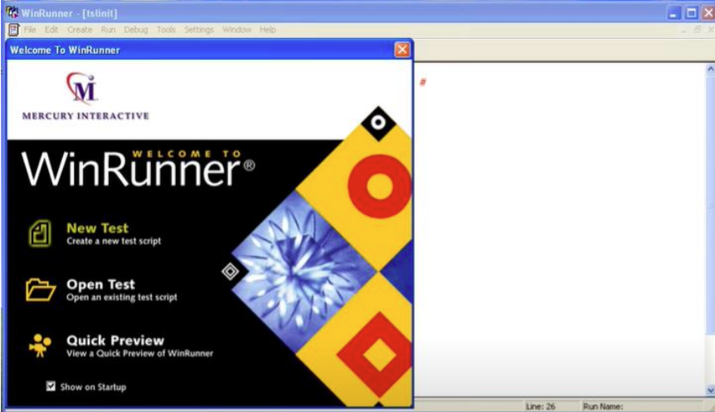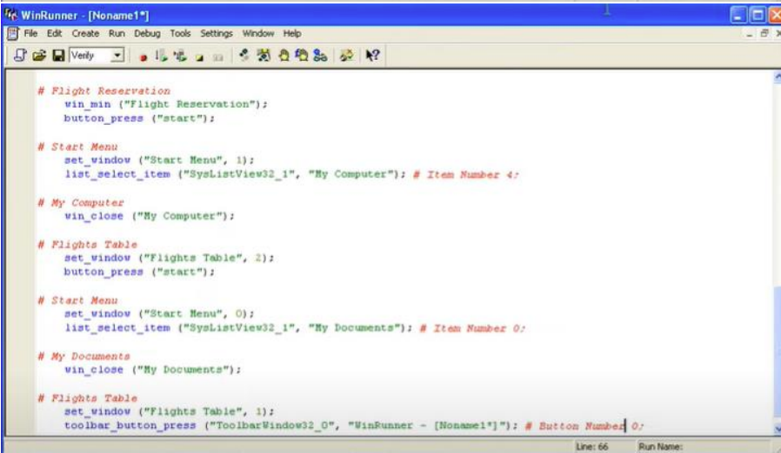

## **Result:**

The Testing process in WinRunner flows from the identification of functions, the recording of application activity, the test script management, the execution of tests, and finally the analysis & reporting of the gathered test results. It can be applied on the various software development methods like the Waterfall, Agile, and even the V–V model for the testing phase to be automated in accordance to the functional specification.

# **Viva Questions**

**Q1. Describe the WinRunner testing process.**

There are main 6 stages involved in the WinRunner testing process.

WinRunner testing stages

1. Creating a GUI Map file can help WinRunner to identify GUI objects used in the application for which one wants to test  
2. Tests can be generated by

* + Recording
  + Programming
  + Combining both

3. Running test cases in debug mode can help us to ensure consistency in tests run. Breakpoints in tests, variables monitoring, and ease of control on test runs can make work easy of finding defects.  
4. Running test cases in verify mode to test the application and compares the data of the application with the earlier captured data.  
5. This stage states the status of any test – PASS or FAIL.   
6. In case of any failure of any test case due to some defect, that defect can be directly reported from the Test Results window.

**Q2 Specify the language used in WinRunner.**

WinRunner used TSL-Test Script Language. It is similar to C.

**Q3. Brief about the test scripts you’ve created in WinRunner.**

WinRunner test scripts contain statements written in Mercury Interactive’s Test Script Language (TSL). We can modify the recorded test scripts, either by adding more programming elements and TSL functions or by using Function Generator, a WinRunner’s visual programming tool.

**Q4. What’s there in Wrun.ini File?**

Wrun.ini the the file is the setup configuration file for WinRunner.

**Q5: What does it mean by the logical name of any object?**

The logical name of any object is nothing but the text label of that object. This makes the code easily understandable and readable.